Name _______________________ Form_____ Date________
Control work
Variant 1
- Complete the sentences with the words from the box
1. When we want to watch a new film, we go to the __________________
2. People can swim in the ___________________ all year round.
3. This house isn’t old, it’s ___________________________
4. You can get to the museum by __________________ or on foot
5. There are a lot of ________________ and big trees in the park
6. There is a bus stop right _____________ the bank
2.Put the verbs in brackets into the Past Simple or Present Perfect Tense
- Jack ____________ (to be) to Spain already.
- He _____________ (to be) there last summer
- I __________________ (to do) the shopping already.
- I ________________(to come) home an hour ago.
3.Fill in was, were, wasn’t, weren’t
- Ann _________ at home yesterday. She went to the cinema
- It ___________ sunny last Monday. It didn’t rain.
- ______________ you at school yesterday? I didn’t you there.
- Children ___________ at the seaside last summer. They went to the mountains.

4.Look at the pictures and write what the weather is like
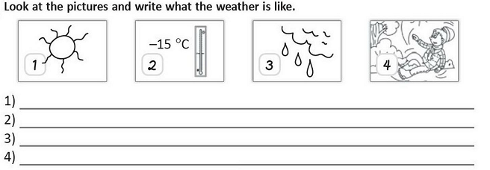

Name _______________________ Form_____ Date________
Control work
Variant 2
1.Complete the sentences with the words from the box
- You can get to the post office by underground or on_________________________
- You can see a lot of different animals in the _____________________________
- There is a café _______________________ to the cinema
- When you are ill, you go to _______________________
- Turn left at the _________________________ and go straight on.
- There is a modern train ________________________ not far from the supermarket

- Put the verbs in brackets into the Past Simple or Present Perfect Tense
- We _______________ (to see) this film already.
- We _________________ ( to see) it last Friday.
- She ________________ ( to be) to Great Britain already
- She ________________ ( to go) there two years ago

- Fill in was, were, wasn’t, weren’t
- My parents __________ at home yesterday. They didn’t go to the restaurant.
- It ____ sunny two days ago. It rained
- Den ___________ at school yesterday. He didn’t go to the dentist
- The tasks in the English tests ____________ difficult. All children got good marks for it
4.Look at the pictures and write what the weather is like.
